How did the introduction of Stemmed Points affect Mobility and Site Occupation during the Late Pleistocene in Korea?

08 May, 2023

We use models from human behavioral ecology to examine stone artifacts from 23 sites in Korea to investigate mobility and site occupation patterns during the Late Pleistocene. This is an important period because new tools, such as stemmed points and blades, appeared in the archaeological record. We focus on two questions: what changes in foragers’ landscape use were associated with the introduction of new tools? And what changes in the way people use habitation sites and mobility were associated with the new technology? To answer these questions we present quantitative analyses of artifact volumetric density, retouch frequency, composition of toolkits, and artifact raw materials. We explore environmental and demographic contexts by applying paleoclimate simulations and summed probability distribution models. We find that quartz and side scrapers, in addition to cores and choppers, remain dominant in assemblages before and after the introduction of stemmed points throughout the Late Pleistocene. Our results show that forager groups using stemmed points may have been associated with occupation of marginal or extreme environments. Groups with stemmed points were associated with expedient technologies, indicating residential and less mobile behaviors. The environmental context of this technological innovation was a gradual decrease in temperature into the LGM. Population increased before the appearance of stemmed points.

# Keywords

Human Behavioral Ecology, Stemmed points, Mobility, Site occupation, Landscape use, Summed Probability Distribution, Pleistocene, Korean Late Paleolithic

# Introduction

The appearance of stemmed points (Figure 1) in the Late Pleistocene (ca. 42-35 ka) in Korea is often assumed to have transformed forager lifeways because it was thought to have indicated more specialized hunting practices (Chang, 2013; Seong, 2008). Stemmed points are projectile points made from an elongated flake or blade with slight retouch on the distal end to shape an acute tip and on the proximal end to make a stem, which connects to a shaft. These types of artifacts are often called tanged points in the western hemisphere (Ivanovaitė et al., 2020; Serwatka and Riede, 2016), but we use ‘stemmed point’ here to distinguish from Bronze Age stone projectile points that have long been called ‘tanged points’ in Korea. Stemmed points are likely to have been projectile weapon tips because the stem of these tools is considered to represent a hafting projection used for joining the lithic to a wooden shaft. If these artifacts were projectile weapon tips, then stemmed points represent the first appearance of hafting technology in Korea. However, most open sites in Korea do not preserve organic remains due to acidic soil, so shafts have not been found. There are very few limestone cave sites containing human fossils or faunal remains (e.g. Durubong and Jeommal Cave), which located in constrained area to access in North Korea or have been rarely analyzed to directly apply to other archaeological research(Bae, 2013). Therefore stone artifacts such as stemmed points are our only window to examine hunting and subsistence strategies. Here we apply a behavioral ecological framework to explore questions about the implications of the appearance of this new technology. We use data from 23 sites in South Korea to explore changes in the way people occupied the landscape, the way people used sites, and the social and ecological contexts associated with the appearance stemmed points, and the blade industry that followed.

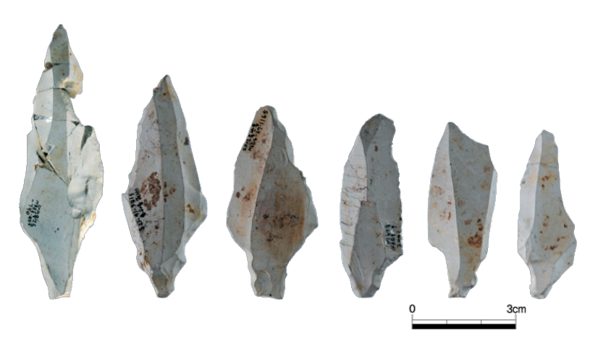

Figure 1: Stemmed points from Yongsandong site

Previous work on this technological change in Korea has focused on issues of the transition from the Early to the Late Paleolithic and modern human dispersals (Bae, 2017; Bae, 2010; Norton and Jin, 2009; Seong and Bae, 2016). To our knowledge, the implications of the appearance of stemmed points for forager mobility and site use have not been explored in detail. Here, we attempt to identify patterns of mobility and site occupation through analysis of the stone artifact assemblages using Human Behavioral Ecology (HBE) models. Drawing on established relationships between lithic technology and forager mobility (Capriles et al., 2018; Hiscock, 1994; Kuhn et al., 2016; Kuhn, 2004, 1994; Kuhn and Miller, 2015; Seong, 2015, 2008; Shott, 1986), we hypothesize that the appearance of the new hunting tool might reflect a preference for more portable and efficient technologies, that were part of a broader strategy of moving frequently and further, possibly as an adaptation to environmental or population changes.

# Late Pleistocene Lithic Technologies in East Asia

In the Eastern hemisphere, some of the most striking technological innovations during the Late Pleistocene are found in Northeast Asia, such as northern China, Japan and Korea. These innovations include blade technology, high frequencies of retouched blade tools, several novel tools such as projectile points, stemmed points, end scrapers, burins, denticulates, ground stone tools etc, and frequent use of high-quality raw materials (Bae et al., 2017; Bae, 2017; Bar-Yosef, 2002; Bar-Yosef and Kuhn, 1999; Brantingham et al., 2001; Lee et al., 2017; Nakazawa and Bae, 2018). Previous work has argued that the appearance of new stone artifact technologies in this region may be linked to modern human dispersals (Bae et al., 2017; Bae and Bae, 2012; Bae, 2010; Seong, 2008). For example, the new dating results from Zhoukoudian Upper Cave from northern China (35.1–33.5 ka) and material evidence such as ornaments and hominin fossil show close relation to one of multiple dispersal events out of Africa into Eurasia (Li et al., 2018).

The Shuidonggou site in northern China is an important example of the transition from cobble to blade tool industries in the Late Pleistocene of Northeast Asia (Brantingham and Perreault, 2010; Gao et al., 2010; Pei et al., 2012). Shuidonggou Locality SDG 2, which dates to around ca. 32 ka, contains faunal specimens, ostrich eggshell beads, and stone artifacts including blades, retouched flakes, cores, and debris along with well-preserved hearths. In Locality 9 dated to ca. 29 ka, there is a small scatter of stone artifacts consisting of blades, Levallois flakes, cores and other retouched flakes. Excavations at Locality 12 shows that its archaeological context, dated to 13,078–13,296 cal BP, includes ground stone and more than 30,000 microlithics made out of a variety of raw materials such as fine-grained and siliceous rocks. In addition, more than 10,000 animal fossils and bone tools including a tool for fishing nets, an awl, and two needles were excavated (Gao et al., 2014; Pei et al., 2012; Zhang et al., 2016). Shuidonggou shows that although stemmed points are not present at all, a blade technology came from Siberia and/or Mongolia at 41 ka (SDG Locality1 and 9). Advanced core and flake tools were likely to have been locally developed at 33 ka (SDG Locality 2 and 8), and at 10.8 ka microblade technology appears, but the origin is uncertain (SDG Locality 12) (Li et al., 2019; Yi et al., 2014). The microblade technology is argued to have appeared related to changes in mobility associated with colder climates towards the Last Glacial Maximum (LGM) (Yi et al., 2014).

In Japan, Early Upper Paleolithic (EUP) technologies appeared in different regions of the archipelago around 38 ka, accompanied by remains of *Homo sapiens* found in Okinawa Island (ca. 36 ka) (Izuho and Kaifu, 2014; Yamaoka, 2012). These technologies include trap pits, cobble concentrations, hearths, charcoal concentrations, and toolkits including trapezoids, pointed-shaped backed blades, backed points, burins, end scrapers, side scrapers, wedges, beak-shaped tools, axes, edge-ground axes, hammerstones, cobble tools, and anvils (Bae et al., 2017; Izuho and Kaifu, 2014). These innovations have been interpreted as evidence of new foraging methods such as watercraft (marine transport of obsidian from the Kozu Island) and bow-and-arrow technology, driven by increased population and ecological changes and led to the megafaunal extinctions (Bae et al., 2017; Bae, 2017; Kaifu et al., 2019; Morisaki et al., 2019; Nakazawa, 2017; Nakazawa and Bae, 2018; Norton et al., 2010; Yamaoka, 2012). Hafted trapezoids were likely multifunctional tools adapted to the specific environmental settings of the different Japanese Islands (Ono et al., 2002; Yamaoka, 2012). An important example is Ishinomoto 8-ku, which is one of the earliest sites, dated to 39,690–34,790 cal BP, located in Takuma upland of Kumamoto Prefecture. A total of 500 stone artifacts, mostly chert and andesite, were discovered including trapezoids, side scrapers, flakes, flake cores, edge-ground axes, and cobble tools (Izuho and Kaifu, 2014). Stemmed points appear in Japan much later than in Korea, dated to between about 15,500 and 13,800 cal BP (Ono et al., 2002; Tsutsumi, 2007).

What makes the Korean Late Pleistocene technological transition distinctive from what we see at Shuidonggou and in Japan? The key difference is that the earliest signs of new technologies in Korean assemblages are stemmed points, followed by blade technologies. This contrasts with China and Japan where stemmed points appear after their first appearance in the Korean Peninsula. Stemmed points from the Bonggok site are currently accepted as the oldest stemmed points, dated to ca. 41.5 ka, and made on elongated flakes (Bae et al., 2017; Seong, 2015, 2009). After blades became widespread in Korea at ca. 27 ka, they were used to make the stemmed points, and the shape of points became more standardized with one or two ridges on the dorsal side and a triangular cross section. Replacing flakes with blades as blanks of the stemmed points led to an increase in quantity of the points over time. In addition to the stemmed points, flake tools became more complex, with a greater diversity in both type and size along with continuously used core tools during the Late Pleistocene (Bae, 2010; Lee, 2016, 2013). A notable exception to this pattern is the recently excavated Hajinri site which is an outlier with both stemmed points and blades appearing together at 42 ka (Lee et al., 2018).

There have been several attempts to explain this technological transition and they can be summarized into two competing models: ‘heterogenic’ migration (Bae, 2010) or *in situ* evolution (Seong, 2009). The migration model argues that the new blade industry including stemmed points, and the earlier coarse flake tradition including large cores, polyhedrons, choppers, and even handaxes, came from different origins as the result of continuing influx of modern human migration from two routes. Bae (2010) explains that blade and stemmed points arrived in the Korean peninsula from Siberia, Mongolia, or other regions of northeast China following the Liaohe and Sunghe rivers around 35 ka with the earliest evidence of blades in those regions. He assumes that core and flake industry come from southern China based on the existence of similar assemblages in both Korea and southern China. In addition, the genetic studies of two “Asian-specific” Y-chromosome haplogroups (O3-M122, D-M174), mtDNA and autosomal SNPs, and other analyses verify that modern humans initially arrive in southern China and the population migrated to northward (Bae et al., 2013; Lee, 2013).

The alternative model, which we call the ‘*in situ*’ model claims that stemmed points and other Late Paleolithic technologies, including blade industries, autonomously emerged in the south of the Korean peninsula, with no apparent external influence (Seong, 2008). This claim is supported by Korea having the earliest appearance of stemmed points in Northeast Asia, at sites such as Bonggok, Hwadaeri, Hopyeongdong, and Yonghodong dated to approximately 42-35 ka BP (Seong, 2009). Seong(2009) presents the increased blade-to-flake ratios of lithic assemblages after the appearance of stemmed points as support of the *in situ* model, based on the premise that the blade industry represents a new exogenous technology while flakes indicate a continuing local one.

## Behavioral ecology and forager land use behaviors

Our brief review of Late Pleistocene technological innovations in Northeast Asia shows that previous work has largely focused on the timing, location, origins and description of these new tools (Bae, 2010; Lee, 2016, 2013; Seong, 2009, 2008). Modeling the land-use behaviors associated with these assemblages has rarely been undertaken. We focus on the appearance of stemmed points in Korea because these are a new technology that likely represented new hunting behaviors. This is because the hafting implies throwing techniques that can reach long-distance targets (Keeley, 1982; Kuhn and Miller, 2015). We draw on behavioral ecological theory to model the effects of this technological change. Behavioral ecology theory is well established in international archaeology and offers structured models and testable hypotheses based on optimality assumptions derived from principles of economic rationality and environmental adaptation (Prentiss, 2019; Winterhalder and Smith, 1992). Specifically, we use the standard patch choice model, which is built around the widely-used marginal value theorem, to predict that forager mobility between patches and inter-patch travel times will increase when resource patch productivity decreases (Bettinger and Eerkens, 1997; Llano, 2015; Smith, 1991; Smith et al., 1983; Wolverton et al., 2015). We model individual artifact types as a kind of resource patch. Foragers may find a more costly and complicated technology (such as stemmed points, relative to flakes) optimal if they have a long cumulative time in use, if they are maintainable and reusable in a landscape where lithic raw material supply is uncertain (Bleed, 1986; Torrence, 1983). That is, foragers may move to a patch where they can stay longer (i.e. prefer to make and use an artifact type that has a long and extendible use-life) when they are not certain of the productivity and travel times of other patches (i.e. the productivity and use-life of other artifact types) (Kuhn and Miller, 2015).

We ask two questions to investigate the period around the introduction of stemmed points in Korea. First, what changes in foragers’ landscape use were associated with the introduction of the new tools? Specifically, was the use of stemmed points associated with occupation of marginal or extreme environments? Our assumption here is that this new technology, and the ability to reach long-distance targets, might have allowed foragers to explore and sojourn in less productive landscapes by increasing their mobility. For example, in Australia during the mid-Holocene, Hiscock et al. argue that the first appearance of microlithics in many locations represent a portable and multi-functional toolkit that minimize travel expenses and increase tool readiness to adapt to patchy and unpredictable resources associated with environmental change (Hiscock et al., 2011; Hiscock, 1994). Similarly, in Japan, Morisaki et al. (2015) argue that the transition from trapezoid to blades and projectile points around 25 ka in north Paleo-Honshu Island enabled the foragers to extend their occupation into cold grassland landscapes.

Second, we ask what changes in the way people used habitation sites and mobility were associated with the new technology? After the appearance of these new tools, did people tend to be more or less mobile? The stone artifact assemblage from a site can inform us how long individuals or groups stayed and give insights into their activities (Binford, 1979; Holdaway and Davies, 2019; Kelly, 1995; Kuhn et al., 2016). For example, stone artifact density and the frequency of retouched pieces (scaled to the volume of excavated sediment) can be used as proxies to represent occupation patterns (Barton et al., 2011; Clark and Barton, 2017). Assemblages with low density but a high proportion of retouched and backed pieces may indicate the remains of ‘short-term camp’, which is a site for small and ephemeral overnight camp or limited activity station. On the other hand, the combination of high density and low retouched pieces might be expected at logistically organized ‘base camp’, which is a site with greater residential stability, long site occupation and occupied by larger groups (Clark et al., 2019; Clark and Barton, 2017).

# Methods

## Archaeological Sites

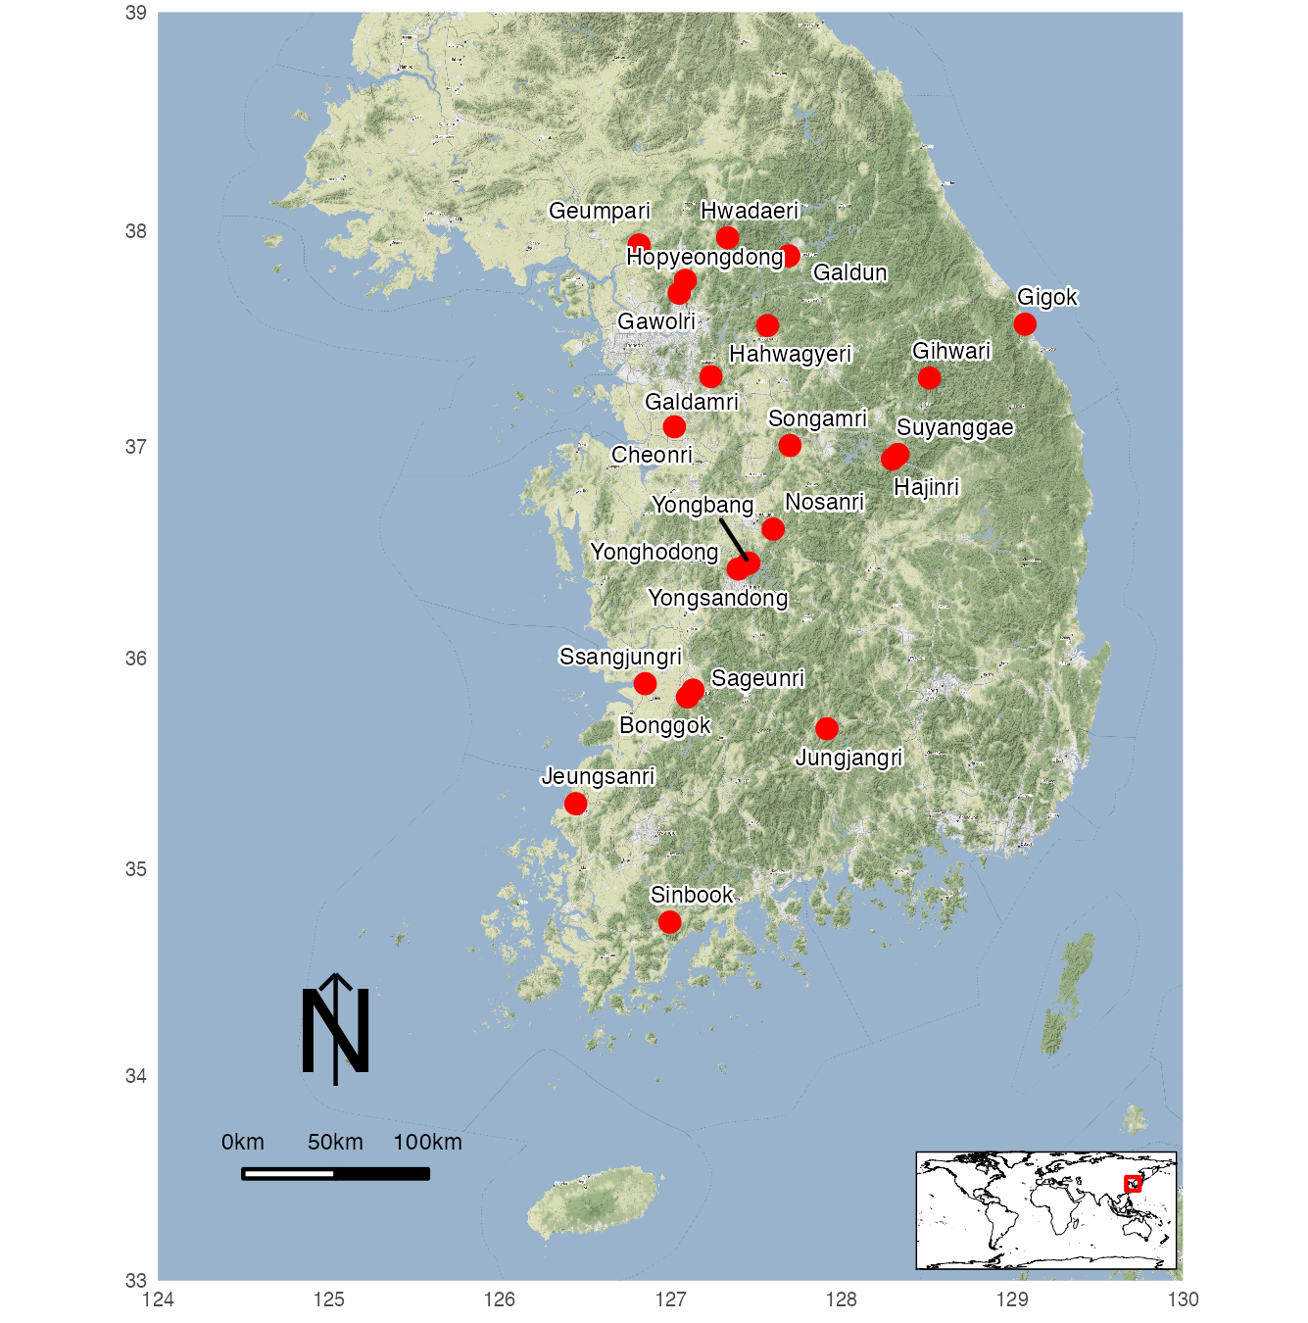

Figure 2: Korean Paleolithic sites mentioned in the text.

After the first Paleolithic sites such as Dongkwanjin and Yondaebong were discovered during the mid-1930s, more than 200 Paleolithic sites have been discovered in South Korea (Lee and Sano, 2019; Lee et al., 2017; Norton, 2000). We selected sites dated to before and after the transition period (42-35 ka) to analyze the process of technological change. It is important to note that the quality of excavation and reporting of Paleolithic sites in Korea varies greatly. Furthermore the stratigraphic integrity of the deposits is also variable, as the sites are open-air localities formed as loose accumulation of artifacts in fluviatile condition or within a colluvium developed at the edge of low-angled slope. To ensure our analysis employs reliable data, we applied a chronometric hygiene protocol (described below) to exclude sites with problematic chronologies and stratigraphy. After applying our protocol to the 200+ sites currently known, we produced a sample of 35 assemblages from 23 sites spanning 49-24 ka (Figure 2). We identified multiple assemblages in a site where culturally sterile deposits separated artifact-bearing deposits, or where stratigraphic units could be identified by major differences in the texture and composition of the sedimentary deposit containing the stone artifacts. For example, the Hwadaeri site has three cultural layers. The lowest horizon at the bottom, dated to 39,000±1400 BP by OSL, contains coarse flake tools made of vein quartz and quartzite. The middle cultural horizon has stemmed points made of porphyry, with quartz and quartzite dominating the assemblage. This layer was dated to 31,200±900 BP by radiocarbon dating and 30,000±1,700 BP by OSL. The uppermost layer, dated to 22,000±100 BP by OSL, contains blades, scrapers, awls, and denticulates (Seong, 2009). We obtained the data from published excavation reports held by provincial museums.

## Stone Artifact Assemblages

The 35 assemblages consist of (non-blade) cores, blade cores, blades, flakes, debris, hammers, choppers, planes, polyhedrals, side scrapers, end scrapers, notches, cleavers, stemmed points, awls, denticulates, burins, handaxes, blanks, knives, handadzes, peaks, flatters, flakers etc. We excluded some artifacts from our sample because of uncertainty about their typology. The stone artifacts from all of these sites are stored in museums located throughout South Korea, and have been briefly described in Korean language excavation reports. We have visited most of these collections to obtain permission to study the materials directly.

## Methods for Analyzing Stone Artifact Assemblages

To answer our two research questions, we compiled information about artifact density, retouch frequency, toolkit composition, raw materials, site elevation, and radiocarbon ages for the sites in our sample.

Artifact volumetric density is defined as the total number of artifacts per cubic meter of excavated sediment, and serves as a proxy for the accumulation ratio of artifacts (Clark et al., 2019; Clark and Barton, 2017). We used these density values to evaluate mobility and land-use practices of hunter-gatherers during the Late Pleistocene. Retouch frequency is the number of retouched tools divided by the total number of artifacts in an assemblage. This value represents mobility and duration of site occupation based on the assumption that tool reduction is a tactic to extend the use-life of a tool by generating sharp, usable edges while minimizing the cost of transporting tools or bulky raw materials by reducing the total load weight (Buvit et al., 2014; Clark et al., 2019; Kuhn, 1990). In other words, producing and carrying highly retouched tools increased tool portability and efficiency by decreasing the size of both individual tools and the assemblages so that hunter-gatherers could move often or further, or both (Andrefsky, 1994; Davies et al., 2018; Kuhn, 2004, 1994, 1991). Combining these two proxies, the artifact volumetric density and the retouch frequency, we infer whether or not the hunter-gatherers were residentially mobile or logistically organized. If the assemblage in a site has a high artifact density and small proportion of retouch, we interpret it as a more expedient assemblage that represents “base camps” or “residences”, while lower artifact densities with higher proportions of retouched pieces shows a more curated assemblage and indicates either residential mobility or certain task groups away from residential sites (Clark and Barton, 2017; Riel-Salvatore and Barton, 2004).

We calculated toolkit composition by analyzing tool and debitage frequencies to identify changes in the assemblages during the study period. Toolkit composition helps us answer the question of how site occupation patterns changed before and after the appearance of new technology. The type and proportion of retouched tools and knapping products, including debris and hammerstones, provide information about settlement patterns based on a premise that more activities are conducted with a wider range of tool types for longer occupation (Buvit et al., 2014; Centi et al., 2019; Garcı́a-Medrano et al., 2017). For example, we interpret small sized assemblages with a low diversity of tools as representing a short duration of site occupation (Buvit et al., 2014; Shott, 2010).

Our study of raw material consumption patterns assumes that stone tool was transported and utilized to optimize mobility and minimize risks of not having artifacts when they were needed (Andrefsky, 1994; Brantingham, 2003; Brantingham et al., 2000; Yue et al., 2020). It follows that the representation of raw materials in an assemblage can be an indicator of site occupation patterns. For example, a large variability of raw materials in a site can suggest long-term settlement, while a small assemblage of exotic raw materials can indicate higher mobility (Valde-Nowak and Cieśla, 2020). Here we quantify the specific raw materials that relate to the appearance of a new technology, and investigate site occupation patterns by examining changes in the proportions of raw material types in the assemblages.

## Methods for Analyzing Environmental Context

In addition to these data on human behavior from the stone artifact assemblages, our HBE models require environmental proxies to build hypotheses of behavioral change influenced by the surrounding environment. However, there are few paleoenvironmental proxies in Korea relevant to our study period. For example, geoarchaeological observations simply suggest that environment of the period was overall cooler and drier during MIS 3 (Bak and Lee, 2017; Chang, 2013; Choi, 2011; Han, 2008; Im and Choo, 2015; Seong, 2008). To supplement the limited availability of high-resolution local proxies, we used climate information from a simulated data set of paleoclimate including global monthly temperature, covering the last 120,000 years (Beyer et al., 2020). We extracted annual temperature values from the data generated by Beyer et al. (2020) for all site locations in our sample. In addition, we extracted site elevation values from a raster, as a proxy to represent environmental variation at local scales, to assist in identifying how these impact mobility and site occupation, and their relationship with the stemmed points.

## Methods for Analyzing Demographic Context

We used radiocarbon dates as a proxy for human population to infer the demographic context of technological change. Summed probability distributions (SPD) of radiocarbon dates are widely used by archaeologists to infer temporal trends in past human populations (Bamforth and Grund, 2012; Contreras and Meadows, 2014; Rick, 1987; Riris and Arroyo-Kalin, 2019; Shennan et al., 2013; Timpson et al., 2014). Despite concerns about limitations of the validity of SPD (Bamforth and Grund, 2012; Carleton, 2021; Williams, 2012), several studies have shown good agreement between SPDs and other archaeological indicators (e.g. site counts, settlement size) so this method may allow a first approximation of population fluctuations (French and Collins, 2015; Palmisano et al., 2017). Although this is often used with samples of thousands of ages, this method can also be useful for small sample sizes. For instance, Timpson et al. (2014) apply SPD to 93 ages from Eastern Middle Sweden and demonstrate that the result is equivalent to a larger sample size (n = 243). In addition to the 93 radiocarbon ages from our targeted sites, we included all available dating results (540 ages) from other Korean Paleolithic sites that have younger and older assemblages. We compiled a total of 633 dates from 113 sites and applied a chronometric hygiene protocol to assess the reliability of radiocarbon determinations in relation to target events. Following the criteria from Napolitano et al. (2019) and Fitzpatrick (2006), we kept ages from dating short-lived terrestrial material (i.e., plant remains) and charcoal, and having laboratory name and number. We excluded OSL dates and sites with only one date. This resulted in a sample of 400 radiocarbon ages from 23 sites which we use to examine connections between population trends during the Late Pleistocene in Korea and technological innovation.

There is a debate about whether past population growth has played a role in technological change (Hosfield, 2005; Kline and Boyd, 2010; Shennan, 2001). Shennan (2009) observed a correlation between population decrease and technological simplification in his study of lithic arrowheads from the southern Scandinavian Mesolithic. He found that the lithics became less complex, and point shape changed as the population level dropped. By proposing the generalized null demographic model built on cultural transmission theory, Lycett and Norton (2010) also claimed that relatively lower effective population sizes in East Asia could be strongly associated with a lower frequency of handaxe sites, a lower percentage of bifaces, and morphological difference between East Asian handaxes and classic Acheulean artifacts. They also suggested that a lack of Levallois technologies in East Asia might be similar to the previous example of handaxe. On the other hand, Collard et al. (2013) argue that regional archaeological data do not support the population-driven models. For example, Buchanan et al. (2016) concluded that changes in point types from >13,000 years ago to 400 years ago in Texas were related to environmental risk, and not dependent on population size.

We used SPD to test for correlations between population, environmental proxies and technological change. We used the R package ‘rcarbon’ (Crema and Bevan, 2021) to perform statistical analyzes and conduct model testing using Monte Carlo methods (Crema et al., 2016; Palmisano et al., 2020; Timpson et al., 2014). We generated exponential, uniform, linear, and logistic models and evaluated the model goodness-of-fit by applying Akaike’s Information Criterion (AIC) as a ranking criterion (Bevan et al., 2017; Riris and Arroyo-Kalin, 2019; Sakamoto et al., 1986).

## Reproducibility and Open Source Materials

The entire R code (Team, 2019) used for all the analysis and visualizations contained in this paper is openly available at <https://doi.org/10.17605/OSF.IO/JXWY5> to enable re-use of materials and improve reproducibility and transparency (Marwick, 2017). Also in this version-controlled compendium (Marwick et al., 2018) are the raw data for all the visualizations and tests reported here. All of the figures, tables, and statistical test results presented here can be independently reproduced with the code and data in this repository. The code is released under the MIT license, the data as CC-0, and figures as CC-BY, to enable maximum re-use.

# Results

## Artifact Volumetric Density and Retouch Frequency

Figure 3 shows that there is no strong directional temporal pattern of changes in artifact density. The upper bound of artifact density increases in more recent periods. For example, the density of some assemblages are two or three times higher than others, especially after 30 ka. The inset figure shows that assemblages with stemmed points have higher artifact densities than the assemblages without. With the newer tools, hunter-gatherers may have stayed in the same location for longer duration. We may be seeing site occupation patterns in this sample that represent the long term trend of the use of both base camps or residences, represented by the higher artifact densities, and more briefly occupied camps with lower densities. The most striking result here is that maximum size of base camps increases in more recent periods.

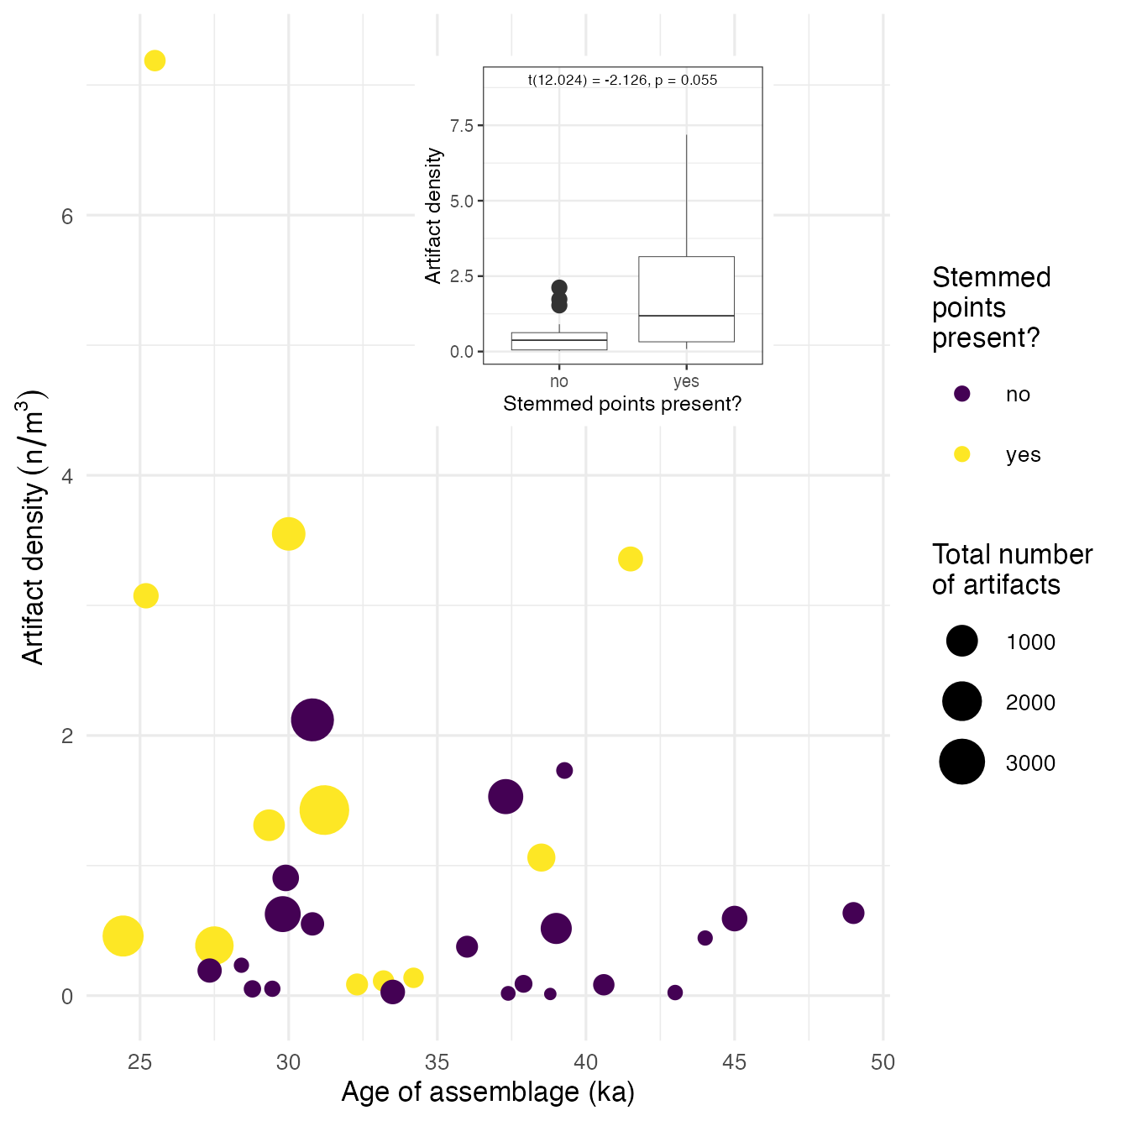

Figure 3: Artifact volumetric density over time. The size of data points represent the total number of artifacts from each assemblage and the colour indicates the presence of stemmed points. The inset plot shows direct comparison of artifact densities for assemblages with and without stemmed points.

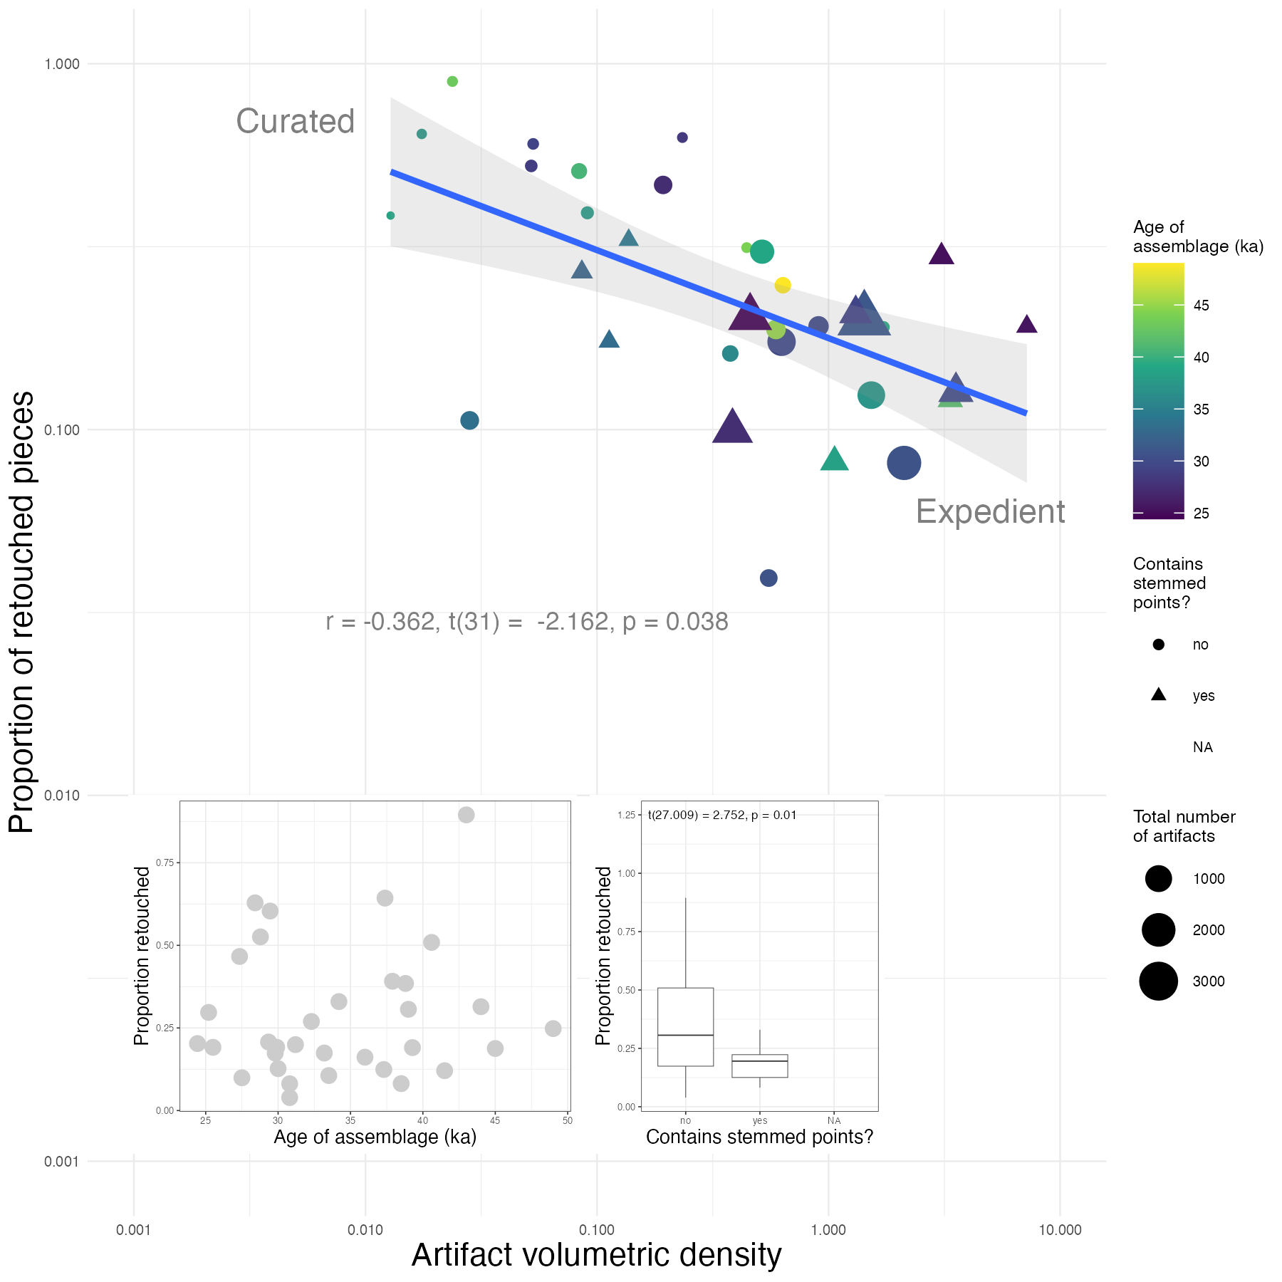

Figure 4: Relationship between artifact density and retouch frequency. The colour of the data points indicate the age of the assemblage, point size indicates assemblage size, and shape indicates presence or absence of stemmed points. Assemblages with higher proportions of retouched pieces and lower densities indicate curated technologies, and assemblages at the other end of the spectrum indicate expedient technologies (Riel-Salvatore and Barton, 2004). The inset plot on the bottom left shows the proportion of retouched pieces in the assemblages over time. The inset plot on the bottom right shows the proportion of retouched pieces in the assemblages with or without stemmed points.

Figure 4 shows a strong pattern of artifacts from less dense assemblages having higher retouch frequencies while more dense assemblages have lower retouch frequencies (t(31) = -2.162, p = 0.038), further showing a spectrum of site functions in this sample. As we saw for artifact density, there are no clear directional chronological trends in retouch frequencies. Assemblages containing stemmed points tend to have substantially fewer retouched pieces compared to assemblages without stemmed points (t(27.009) = 2.752, p = 0.01).

## Toolkit Composition

In 5 we see that side scrapers are the major part of most assemblages and are present in all assemblages. For example, more than 70 percent of the two assemblages from Hwaderi are side scrapers. The proportion of side scrapers shows a striking trend over time, rising to a peak at 38-39 ka, and declining thereafter. In addition to side scrapers, cores also exist in all assemblages, often as a high proportion. The proportion of choppers is lower in more recent assemblages. Stemmed points first appeared in Hajinri around 42 ka and were typically found in assemblages that contain blades, except for Songamri-A. The earliest blades and blade cores are also recorded from Hajinri but the date of this site is an unusual outlier because the stemmed points and blades are highly standardized and refined, which are only found at other sites much later in time. Bonggok site, which is the second-earliest site for stemmed points in our sample, also includes blades but it has not been demonstrated that those artifacts, as well as other earlier blades, are actual blades or elongate flakes without accompanying blade core. Aside from the outlier site Hajinri, blade cores first appeared in Suyanggae-C at 34.3 ka. Other artifacts, including burins, denticulates, end scrapers, handaxes, knives, notches, planes, and polyhedrals made up a small proportion of the assemblages and show no directional chronological change.

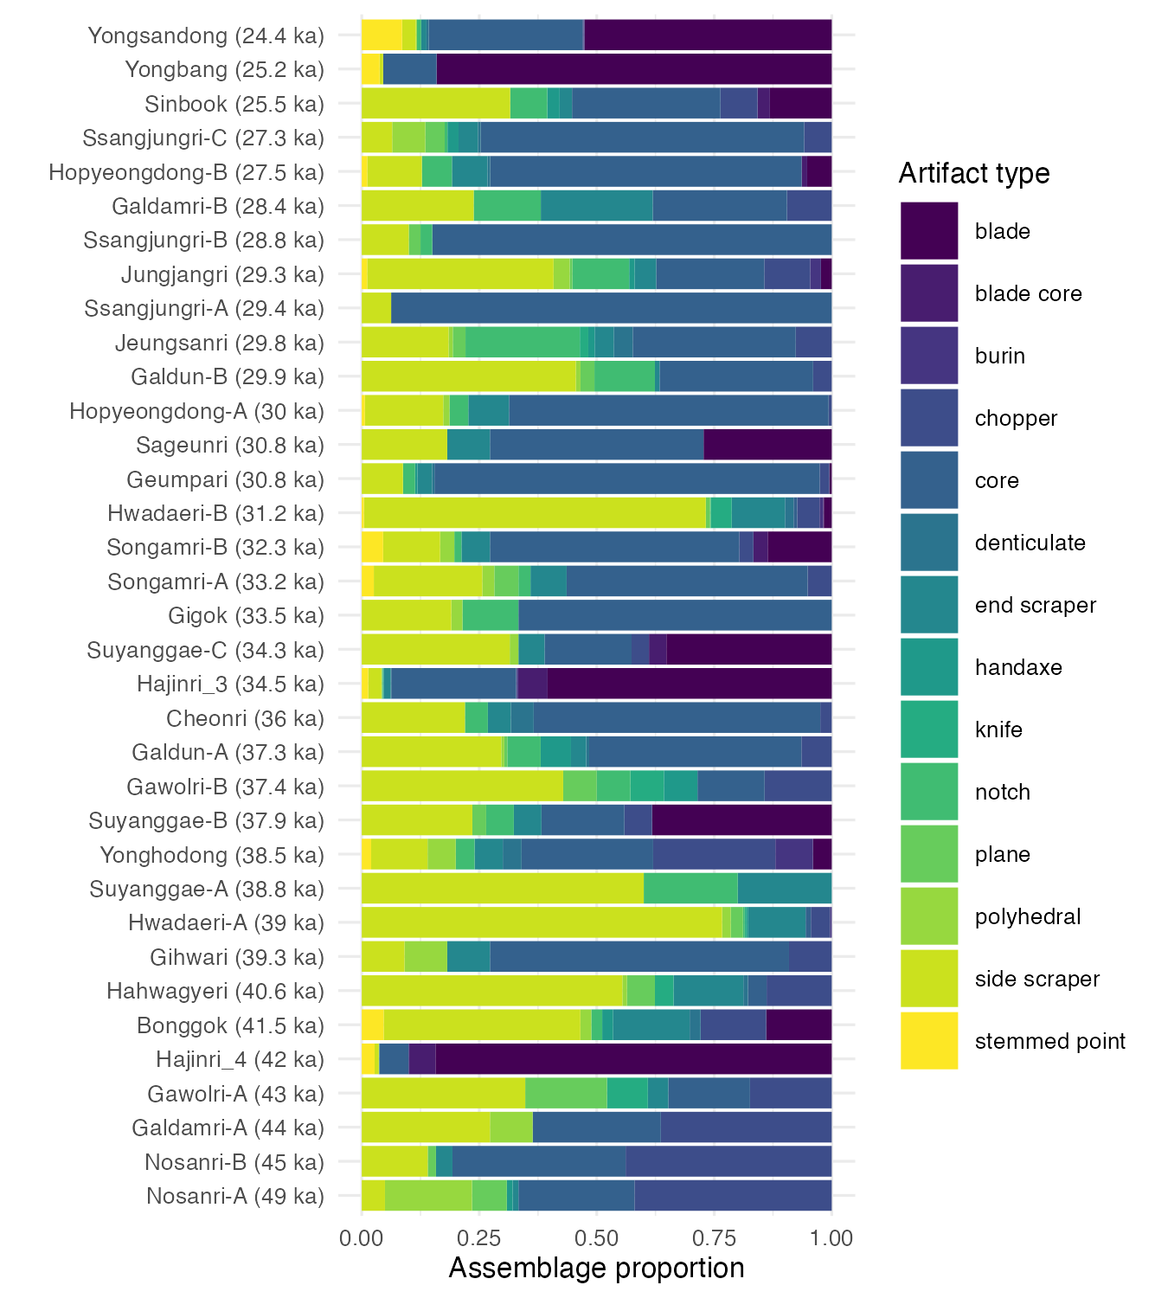

Figure 5: The composition of each assemblage. We excluded artifacts related to manufacturing processes such as pebbles, hammers, flakes and debris, and artifacts that appeared only in a few assemblages including points, beak shaped pieces, awls, and anvils, and unknown pieces. The colour represents different types of tools and the assemblages are placed in chronological order.

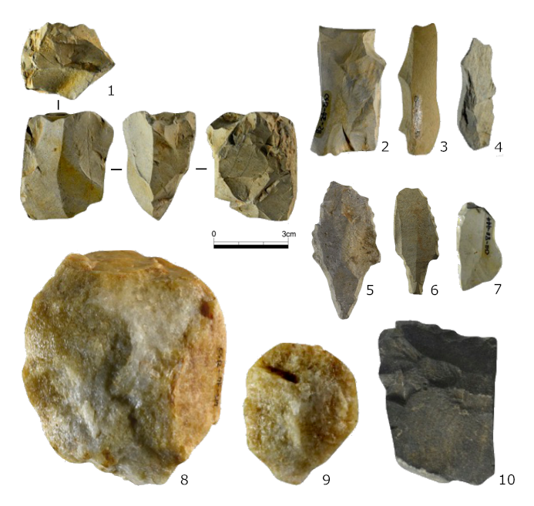

Figure 6: Stone artifacts from Songamri site. 1. Blade core, 2~4. Blades, 5~6. Stemmed points, 7. Side scraper, 8. Chopper, 9~10. Side scrapers.

## Raw Materials

Quartz, quartz vein and quartzites were the most frequently found raw materials, and they were constantly used throughout the Late Pleistocene (Figure 7). For example, both Galdamri-A, dated to 44 ka with a small assemblage, and Hopyeongdong-B, dated to 27.5 ka with a larger assemblage, consist of only the quartz related materials. The use of chert, hornfels, rhyolite, and shale increased after 42 ka, but these raw materials remained a small proportion of assemblages until 25 ka. They are very suitable to make elongate blades and stemmed points because of the predictability of flaking afforded by their fine-grained texture. For example, Hajinri has the largest number of stemmed points (n=86) among the assemblages studied here, and most stemmed points from Hajinri are made from shale. Other raw materials, such as porphyry and sandstone, were found in just a few assemblages in small proportions.

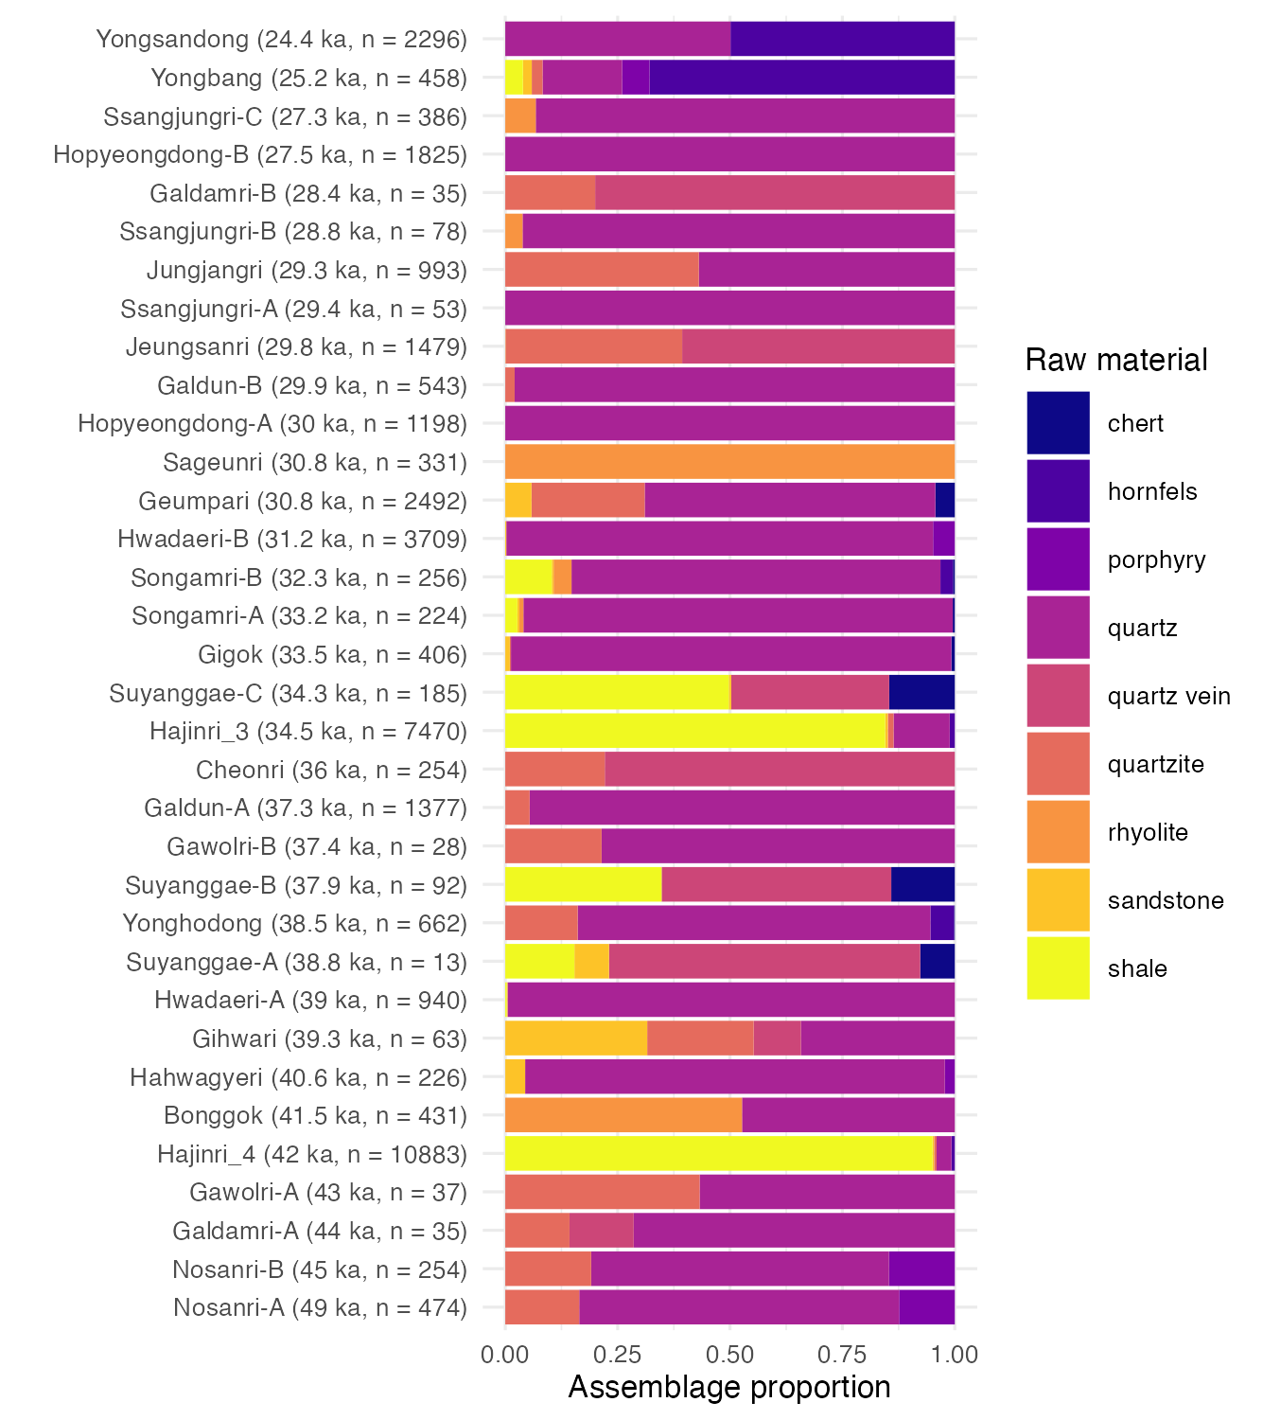

Figure 7: The composition of raw material type in each assemblage. We excluded raw materials that are included in less than 5 assemblages including crystal, basalt, ironore, slate, limestone, granite, gneiss, tuff, amphibolite, andesite, grit, metamorphic-rock, quartzitic-gneiss, siliceous-schist, and unidentified ones. Hornfels are shown in four assemblages but since it occupies more than half of the Yongsandong and Yongband assemblages, we included it in the plot. The color represents different types of raw materials, and the assemblages are placed in chronological order.

## Environmental Context

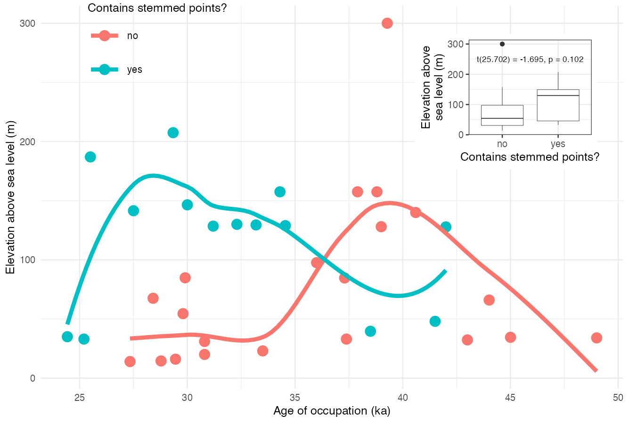

Figure 8: Site elevation by the age of the deposit. Colour indicates presence/absence of stemmed points. The lines display a locally weighted regression. The inset plot shows a direct relationship between the site elevation and stemmed points.

Figure 8 shows that people occupied sites located at a wide variety of elevations from around 0 to 200 meters above sea level. Elevation correlates with the ecological diversity of plants and animals in Korea (Park and Kim, 2020; Sohn et al., 2019) and thus elevation is a suitable proxy for the environmental context of human behavior. As we saw for artifact density, there is an increase in the upper bound of site elevation in more recent times. The most striking pattern in the elevation data is the substantial difference in elevation between sites with stemmed points and sites without. The distribution of elevations of sites without stemmed points is generally lower than the elevations of sites with stemmed points. Although not a statistically significant difference in elevations (t(25.702) = -1.695, p = 0.102), this may indicate that forager groups who used stemmed points were generally more able to occupy higher altitudes, while the groups without stemmed points tended to prefer lower altitudes. According to our locally weighted regression, sites without stemmed points reach a maximum elevation of about 150 m at around 39 ka. Sites containing stemmed points reach a maximum elevation of 175 m at 28 ka. While the elevation difference is well within the total range of elevation throughout the Korean Peninsula (which exceeds 500 m in the more mountainous eastern regions), the slightly higher elevation sites occupied by stemmed point users probably provided better views of the valleys in search of large game.

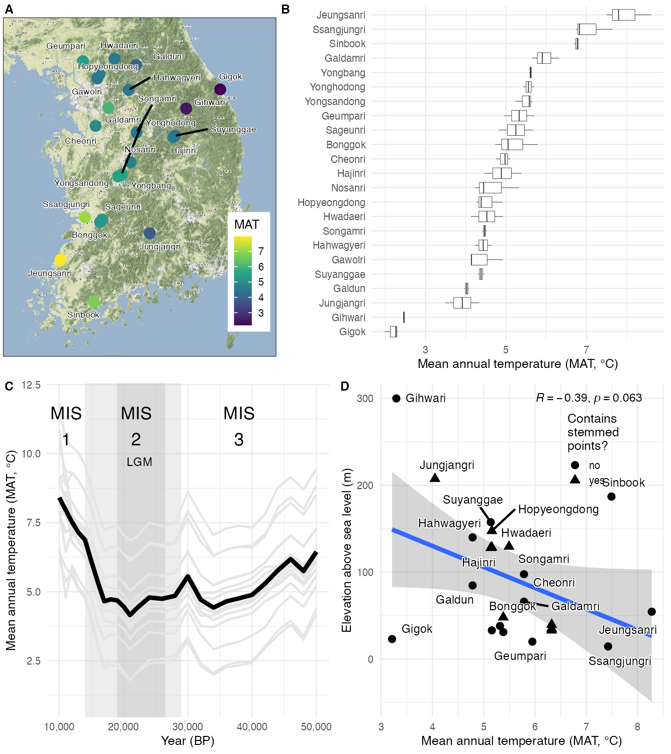

Figure 9: Mean Annual Temperature (MAT) of the Korean Paleolithic assemblages mentioned in the text. A: Site locations and their MAT. B: MAT distributions for each site during the period they were occupied. C: MAT from 50 ka to 10 ka. The grey lines indicate the MAT for each site and the black line is the mean temperature of all sites. The light grey area in the middle of the plot indicates the duration of MIS 2, and the dark grey area represents the duration of the LGM. D: The relationship between MAT and site elevation. The blue line is a linear regression on elevation and MAT with the grey area showing the 95% confidence interval.

Among the sites in our sample there is a variation of about 5 degrees in the mean annual temperature (MAT), mostly controlled by elevation (Figure 9). Through MIS 3, the temperature gradually decreased until the Last Glacial Maximum (LGM, 26.5-20 ka) (Clark et al., 2009). The MAT of MIS 2, including LGM, was relatively stable. The temperature increased again from late MIS 2 towards MIS 1. Compared to the east side of the Korean Peninsula, the west side tends to be relatively warmer. The range of MAT at the sites over our study period is 2-10℃. Gihwari and Gigok sites have the lowest (3℃) and Jeungsan-ri site has the highest MAT (8℃). The mean MAT for all sites fluctuated within 4℃ between 50 ka and 10 ka. The first appearance of stemmed points occurred in the middle of the decreasing MAT trend in MIS 3, at 40-35 ka. Figure 9D shows a negative relationship between temperature and elevation. For example, Gihwari Cave site, with one of the lowest MAT distributions, is located in the highest elevation around 300m above sea level. Jeungsanri is located at a lower elevation and has one of the highest MAT distributions.

## Demographic Context

Figure 10 shows the summed probability distribution (SPD) of the radiocarbon ages from the sites in our sample overlaid with distributions (indicated by the grey envelopes) generated from four models of demographic change for the period 50 ka to 10 ka (linear, exponential, logistic, and uniform). The fit of models to our observed SPD was computed using 1000 simulations, and the resulting global p-values indicate significant deviations in the observed SPD from the modeled distributions. Overall, the linear model is the best fit with the observed SPD, having the lowest AIC value of the three models where we could compute this. We can say that the population did not grow or decline strongly logistically, exponentially or linearly during the Late Pleistocene, but instead followed a noisy distribution. The most striking results here are the SPD showing a steady growth rising to a peak at about 43 ka, indicated by the positive deviations from the three null models (shaded in red), except for the logistic model. During the transition period, SPD hits another peak at about 35ka. Then the SPD goes down with minor deviations to a lower level at 31.5 ka. From 27 ka the SPD constantly fluctuates with temporary positive deviation until 20ka.

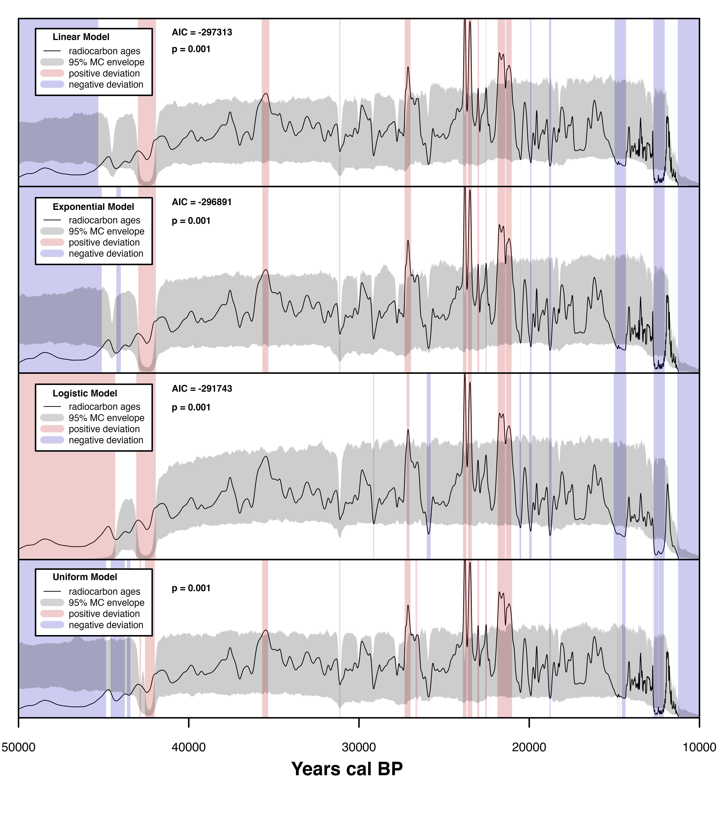

Figure 10: Summed probability distribution of 400 radiocarbon dates. The black solid line represents actual radiocarbon ages. The grey shaded region shows the Monte Carlo envelope that encompasses the 95% confidence interval for the null models. The red and blue vertical bands highlight the portions of the SPD where positive and negative deviations are detected. We applied linear, exponential and logistic to AIC along with the logistical growth model (fit) to evaluate each model (Riris and Arroyo-Kalin, 2019). We excluded the uniform model because it has no fitted curve or surface to evaluate. The best fit model has the lowest AIC score. In this case, the linear model is the best fit for the observed data

# Discussion

Our study focused on two questions: (1) what changes in foragers’ landscape use were associated with the introduction of the new tools?; and (2) what changes in people’s mobility and use of habitation sites were associated with the new technology? Overall, our results show that assemblages with stemmed points tend to have higher artifact densities and lower proportions of retouched pieces. Quartz and side scrapers, in addition to cores and choppers, remain dominant in assemblages throughout the late Pleistocene. The environmental context of this technological innovation was a gradual decrease in temperature into the LGM. Analysis of radiocarbon ages suggest a population increase before the appearance of stemmed points.

## Artifact Volumetric Density and Retouch Frequency

We examined the artifact volumetric density and retouch frequency to understand the difference in mobility strategies and site occupation patterns associated with the introduction of stemmed points. The analyses are based on the premise, established on global ethnographic data, that highly mobile groups carried lightweight toolkits with more retouched and easily replaceable composite tools, and left smaller amounts of artifacts at sites as a result of short-term occupations. These curated technologies reflect an investment of time and effort in stone artifact manufacturing and maintenance to minimize travel costs of carrying the tools for high mobility or special purpose foray groups. On the other hand, less mobile groups produced fewer retouched tools and left higher densities of artifacts generated from long-term occupations. These expedient technologies are more typical for groups with greater residential stability who can make, use, abandon, and remake their tools frequently in the same location (Binford, 1979; Clark et al., 2019; Kuhn, 2014, 1994; Meignen et al., 2006; Torrence et al., 1989; Vaquero and Romagnoli, 2018). As mentioned above, the sites we addressed here are all open-air localities with limited material remains to infer the clear view of subsistence strategies, nevertheless, our data are highly consistent with these concepts of curated and expedient technologies, showing a strong pattern of artifacts from less dense assemblages having higher retouch frequencies, and more dense assemblages having lower retouch frequencies. In general, the new technology of stemmed points was more associated with expedient technological strategies. Our results show that foragers with stemmed points tended to stay in the same site for longer periods with higher artifact densities and fewer retouched pieces, compared to assemblages without stemmed points.

If stemmed points were primarily a hunting tool, as prior work has assumed, we might expect foragers to have been using stemmed points in highly mobile groups and stemmed points mostly found in small assemblages at task-specific sites (Chang, 2013; Lee and Sano, 2019). However, our results show the opposite, namely that this new technology was more often associated with expedient technological strategies, implying that the tools may have been multipurpose. Furthermore, our results show that different sites represent different occupation patterns during the time of technological transition, making it difficult to characterize this period with a single land use strategy. Seong claims that transitions from the expedient to curated technology in the Late Pleistocene were neither a straightforward nor unilineal processes and diverse site types can be more related to different occupation purposes including hunting camps, limited activity stations, caches, and so forth (Seong, 2015). Our findings support Seong, with some sites such as Bonggok and Yonghodong containing only two stemmed points, while Yongsandong has 38 points including broken tips and a base. Yongsandong stemmed points are made from blades, dominating the tool kit with 233 blades and other byproducts related to lithic manufacturing including cores and debris made of the same raw materials (i.e. hornfels) (Bae and Bae, 2012; Kim, 2004). In the specific case of Yongsandong it seems likely that stemmed points were manufactured for hunting purposes, which dominated the function of the site. On the other hand, at Bonggok and Yonghodong stemmed points were only a minor part of activities there.

## Toolkit Composition and Raw Materials

Previous work on toolkit composition during the Late Pleistocene of Korea attempted to divide it up into multiple chronological sub-periods. Seong divides five successive assemblage types for the Late Paleolithic in Korea: (1) quartzite and quartz vein artifacts; (2) mostly small quartzite and quartz vein artifacts with some large artifacts such as cores and choppers; (3) stemmed points dominant; (4) typical blade assemblages including stemmed points; and (5) microblade after 30 ka (Seong, 2015). Lee focuses on the Honam region in southwestern Korea and divides the same time frame into two phases; ‘core tool industry with large flake knapping’ during early MIS 3 (59−40 ka), and ‘blade industry with tanged point chiefly’ during late MIS (40−24 ka) (Lee, 2012). Both Seong and Lee mention that core tools made of quartz or quartz vein never disappeared and they point out the appearance of stemmed points and blade technology as an addition, rather than replacement. Our results, covering 49-24 ka and corresponding to the first three types of Seong’s divisions, show that the divisions are subtle, with the continuation of core tools abundantly throughout the Late Pleistocene. In addition, our data show that side scrapers remained as major tools while other tools occupied only a small portion of the assemblages. As stemmed points and blades increased in the toolkits, both choppers and side scrapers went through minor decreases but still remained abundant.

Changes in raw material composition were closely associated with the appearance of stemmed points. Previous studies claim that the existing tools, including choppers, polyhedrals, handaxes and cores were usually made of locally acquired quartzite, while the new tools including stemmed points and other blade assemblages were made of more fine-grained materials such as siliceous shale, hornfels, and obsidian which might be brought from distant sources (Chang, 2013; Seong, 2015). Our data also show that quartz, quartz vein and quartzite were consistently dominant and the use of fine-grained materials including chert, hornfels, rhyolite, and shale, increased after 42 ka, around the time that stemmed points appear. Projectile points, such as stemmed points, benefit from high quality materials which enable high flaking quality, durability and effectiveness of an edge, as well as the creation of well-defined outline forms (Bamforth, 2009). The increased use of finer-grained raw materials likely changed forager mobility patterns to ensure their movements over the landscape supplied them with the materials needed to make stemmed points.

## Environmental and Demographic Contexts

We hypothesized that the introduction of stemmed points might reflect a preference for more portable and efficient hunting tools, as an adaptation to environmental or demographic changes. As the first composite tool appearing on the Korean Peninsula, stemmed points represent a major change in stone artifact technology. An important quality of composite tools is that the user can easily replace damaged parts, contributing to an increased maintainability of the tool (Cardillo, 2010; Kuhn and Miller, 2015). Combining the stone projectile with a wooden shaft further materials enhances functionality of the tool by improving penetration by increasing weight and sharpness (Browne, 1940). We predicted that the functional advantage of the new composite tool would have allowed foragers to be more effective in less productive or more marginal landscapes. To explore the environmental and demographic contexts related to the technological transition, we examined the distribution of site elevations, and simulated MAT during the Late Pleistocene. The results show that groups with stemmed points generally reached higher elevations, where the MAT was generally lower. This supports our hypothesis that stemmed points were associated with the occupation of more challenging habitats. Furthermore, through MIS 3 the temperature gradually decreased until the LGM, suggesting that stemmed points may have been part of a suite of adaptations to cooler temperatures at any elevation. We see a similar pattern of new technologies enabling expansion into marginal areas at a later time in north Paleo-Honshu Island, Japan, where the appearance of blade and projectile points at about 25 ka were associated with foragers moving into cold grassland areas (Morisaki et al., 2015).

We investigated forager population dynamics to assess if demographic change might be a relevant mechanism to explain the appearance of stemmed points. The output of our SPD models indicate population increasing before the appearance of stemmed points and remaining at the peak with minor deviations until 35ka and then declining after 35 ka. If population dynamics were a key driver, then we expect population to see more frequent and constant positive deviations during the transition period. We conclude that population dynamics were not a major mechanism in the appearance of this new technology. Bae claims that stemmed points are the result of the continuous influx of modern humans from a Siberian migration (Bae, 2010). Our results are partly consistent with this scenario, showing a gradual increase in population before the appearance of stemmed points, however with the evidence currently available we cannot discern if this is endogenous population growth or external migration.

# Conclusion

To understand the change in mobility and site occupation related to the appearance of new technologies during the late Pleistocene in Korea, we examined stone artifacts from 23 sites dated to 49-24 ka. The results show that the forager groups with stemmed points tended to be located at higher elevations. The temperature gradually decreased during the technological transition and after the appearance of stemmed points. Overall, the result indicates that the use of stemmed points was associated with occupation of marginal environments. In addition, the groups with stemmed points had expedient technologies which reflect residential and less mobile land use patterns.

Our findings are limited by the relatively small number of sites and radiocarbon ages currently available. The absence of detailed stratigraphic data limit the chronological resolution for the assemblages in our sample. Furthermore, we currently lack functional data on individual artifact assemblages to support our conclusions about site use to evaluate whether stemmed points were primarily hunting projectiles, or multipurpose, as we have proposed here. With future work we may be better able to distinguish a high density of stone artifacts resulting from a long-term/small group occupation versus a short-term/large group occupation. We acknowledge that our coarse resolution of environmental data is not fully satisfying to patternize the subsistence strategies of forager groups. Therefore we aim to increase the spatial resolution of the data from the sites in our future work. Further research should also aim to identify the mechanisms behind the population increase that we have reported here, was it local population growth, or a result of new groups arriving from outside of Korea?

# CRediT authorship contribution statement

Gayoung Park: Conceptualization, Data curation, Methodology, Software, Validation, Formal analysis, Resources, Writing - original draft, Visualization, Project administration, Funding acquisition.

Ben Marwick: Methodology, Formal analysis, Investigation, Software, Validation, Visualization, Supervision, Project administration, Funding acquisition.

# Funding source

This work was supported by Quaternary Research Center funding, and travel grants from the Department of Anthropology and Center for Statistics and the Social Sciences at University of Washington.

# Acknowledgements

We thank Yongjoon Chang, Seonsook Park, Jaeyoung Kim, Soonmi Lee, Taeyoung Kim, and the staff in Korean national museums, and Sangtaek Lim, Chuntaek Seong, Sangmin Cha, Sooa Kim, Gigil Lee, Myeongjin Choi, and Chanho Park in local archaeological institutions and University museums in Korea for their assistance and support in accessing to the data used in this paper and accommodating our trip to their collections. This work was supported by grant award of Quaternary Research Center and travel grands from the Department of Anthropology and Center for Statistics and the Social Sciences at University of Washington. We appreciate insightful feedback on an early draft from Ben Fitzhugh and Peter Lape.

##### 0.0.0.0.1 pagebreak

# References

Andrefsky, W., 1994. Raw-material availability and the organization of technology. American Antiquity 59, 21–34.

Bae, C.J., 2017. Late pleistocene human evolution in eastern asia: Behavioral perspectives. Current Anthropology 58, S514–S526.

Bae, C.J., 2013. Paleolithic cave home bases, bone tools, and art and symbolism: Perspectives from korea. Hoseo Archaeology 29, 59.

Bae, C.J., Bae, K., 2012. The nature of the early to late paleolithic transition in korea: Current perspectives. Quaternary International 281, 26–35.

Bae, C.J., Bae, K., Kim, J.C., 2013. The early to late paleolithic transition in korea: A closer look. Radiocarbon 55, 1341–1349.

Bae, C.J., Douka, K., Petraglia, M.D., 2017. On the origin of modern humans: Asian perspectives. Science 358, eaai9067.

Bae, K., 2010. Origin and patterns of the upper paleolithic industries in the korean peninsula and movement of modern humans in east asia. Quaternary International 211, 103–112.

Bak, Y.-S., Lee, Y.-U., 2017. Late quaternary paleoclimatic change in the ulleung basin, east sea, korea. Acta Geologica Sinica-English Edition 91, 263–269.

Bamforth, D.B., 2009. Projectile points, people, and plains paleoindian perambulations. Journal of Anthropological Archaeology 28, 142–157.

Bamforth, D.B., Grund, B., 2012. Radiocarbon calibration curves, summed probability distributions, and early paleoindian population trends in north america. Journal of Archaeological Science 39, 1768–1774.

Barton, C.M., Riel-Salvatore, J., Anderies, J.M., Popescu, G., 2011. Modeling human ecodynamics and biocultural interactions in the late pleistocene of western eurasia. Human Ecology 39, 705–725.

Bar-Yosef, O., 2002. The upper paleolithic revolution. Annual Review of Anthropology 31, 363–393.

Bar-Yosef, O., Kuhn, S.L., 1999. The big deal about blades: Laminar technologies and human evolution. American Anthropologist 101, 322–338.

Bettinger, R.L., Eerkens, J., 1997. Evolutionary implications of metrical variation in great basin projectile points. Archeological Papers of the American Anthropological Association 7, 177–191.

Bevan, A., Colledge, S., Fuller, D., Fyfe, R., Shennan, S., Stevens, C., 2017. Holocene fluctuations in human population demonstrate repeated links to food production and climate. Proceedings of the National Academy of Sciences 114, E10524–E10531.

Beyer, R.M., Krapp, M., Manica, A., 2020. High-resolution terrestrial climate, bioclimate and vegetation for the last 120,000 years. Scientific Data 7, 1–9.

Binford, L.R., 1979. Organization and formation processes: Looking at curated technologies. Journal of anthropological research 35, 255–273.

Bleed, P., 1986. The optimal design of hunting weapons: Maintainability or reliability. American antiquity 737–747.

Brantingham, P.J., 2003. A neutral model of stone raw material procurement. American Antiquity 68, 487–509.

Brantingham, P.J., Krivoshapkin, A., Jinzeng, L., Tserendagva, Y., 2001. The initial upper paleolithic in northeast asia. Current Anthropology 42, 735–746.

Brantingham, P.J., Olsen, J.W., Rech, J.A., Krivoshapkin, A.I., 2000. Raw material quality and prepared core technologies in northeast asia. Journal of Archaeological Science 27, 255–271.

Brantingham, P.J., Perreault, C., 2010. Detecting the effects of selection and stochastic forces in archaeological assemblages. Journal of Archaeological Science 37, 3211–3225. <https://doi.org/10.1016/j.jas.2010.07.021>

Browne, J., 1940. Projectile points. American Antiquity 5, 209–213.

Buchanan, B., O’Brien, M.J., Collard, M., 2016. Drivers of technological richness in prehistoric texas: An archaeological test of the population size and environmental risk hypotheses. Archaeological and Anthropological Sciences 8, 625–634.

Buvit, I., Izuho, M., Terry, K., Shitaoka, Y., Soda, T., Kunikita, D., 2014. Late pleistocene geology and paleolithic archaeology of the shimaki site, hokkaido, japan. Geoarchaeology 29, 221–237.

Capriles, J.M., Albarracin-Jordan, J., Bird, D.W., Goldstein, S.T., Jarpa, G.M., Maldonado, S.C., Santoro, C.M., 2018. Mobility, subsistence, and technological strategies of early holocene hunter-gatherers in the bolivian altiplano. Quaternary International 473, 190–205.

Cardillo, M., 2010. Some applications of geometric morphometrics to archaeology, in: Morphometrics for Nonmorphometricians. Springer, pp. 325–341.

Carleton, W.C., 2021. Evaluating bayesian radiocarbon-dated event count (REC) models for the study of long-term human and environmental processes. Journal of Quaternary Science 36, 110–123.

Centi, L., Groman-Yaroslavski, I., Friedman, N., Oron, M., Prévost, M., Zaidner, Y., 2019. The bulb retouchers in the levant: New insights into middle palaeolithic retouching techniques and mobile tool-kit composition. PloS one 14, e0218859.

Chang, Y., 2013. Human activity and lithic technology between korea and japan from MIS 3 to MIS 2 in the late paleolithic period. Quaternary International 308, 13–26.

Choi, S.-Y., 2011. Natural environment of the paleolithic in gangwon region. Journal of Humanity and Science 28.

Clark, G., Barton, C.M., 2017. Lithics, landscapes & la longue-durée–curation & expediency as expressions of forager mobility. Quaternary international 450, 137–149.

Clark, G., Barton, C.M., Straus, L.G., 2019. Landscapes, climate change & forager mobility in the upper paleolithic of northern spain. Quaternary International 515, 176–187.

Collard, M., Buchanan, B., O’Brien, M.J., 2013. Population size as an explanation for patterns in the paleolithic archaeological record: More caution is needed. Current Anthropology 54, S388–S396.

Contreras, D.A., Meadows, J., 2014. Summed radiocarbon calibrations as a population proxy: A critical evaluation using a realistic simulation approach. Journal of Archaeological Science 52, 591–608.

Crema, E., Bevan, A., 2021. Analysing radiocarbon dates using the rcarbon package.

Crema, E.R., Habu, J., Kobayashi, K., Madella, M., 2016. Summed probability distribution of 14C dates suggests regional divergences in the population dynamics of the jomon period in eastern japan. PLoS One 11, e0154809.

Davies, B., Holdaway, S.J., Fanning, P.C., 2018. Modeling relationships between space, movement, and lithic geometric attributes. American Antiquity 83, 444–461.

Fitzpatrick, S.M., 2006. A critical approach to 14C dating in the caribbean: Using chronometric hygiene to evaluate chronological control and prehistoric settlement. Latin American Antiquity 17, 389–418.

French, J.C., Collins, C., 2015. Upper palaeolithic population histories of southwestern france: A comparison of the demographic signatures of 14C date distributions and archaeological site counts. Journal of Archaeological Science 55, 122–134.

Gao, X., Guan, Y., Chen, F., Yi, M., Pei, S., Wang, H., 2014. The discovery of late paleolithic boiling stones at SDG 12, north china. Quaternary international 347, 91–96.

Gao, X., Zhang, X., Yang, D., Shen, C., Wu, X., 2010. Revisiting the origin of modern humans in china and its implications for global human evolution. Science China Earth Sciences 53, 1927–1940. <https://doi.org/10.1007/s11430-010-4099-4>

Garcı́a-Medrano, P., Cáceres, I., Ollé, A., Carbonell, E., 2017. The occupational pattern of the galerı́a site (atapuerca, spain): A technological perspective. Quaternary International 433, 363–378.

Han, C., 2008. Natural environment of the upper paleolithic period in korea. Journal of the Korean Archaeological Society 33, 3–46.

Hiscock, P., 1994. Technological responses to risk in holocene australia. Journal of World Prehistory 8, 267–292. <https://doi.org/10.1007/BF02221051>

Hiscock, P., Clarkson, C., Mackay, A., 2011. Big debates over little tools: Ongoing disputes over microliths on three continents. World Archaeology 43, 653–664. <https://doi.org/10.1080/00438243.2011.624755>

Holdaway, S.J., Davies, B., 2019. Surface stone artifact scatters, settlement patterns, and new methods for stone artifact analysis. Journal of Paleolithic Archaeology 1–21.

Hosfield, R., 2005. Individuals among palimpsest data. The Hominid Individual in Context. Abingdon: Routledge 220–243.

Im, J.H., Choo, C.O., 2015. A study on tree-ring dating and speciation of charcoal found in pumiceous deposit of the quaternary nari caldera, ulleung island, korea. Economic and Environmental Geology 48, 501–508.

Ivanovaitė, L., Serwatka, K., Hoggard, C.S., Sauer, F., Riede, F., 2020. All these fantastic cultures? Research history and regionalization in the late palaeolithic tanged point cultures of eastern europe. European Journal of Archaeology 23, 162–185.

Izuho, M., Kaifu, Y., 2014. The 21 appearance and characteristics of the early upper paleolithic in the japanese archipelago. Emergence and diversity of modern human behavior in Paleolithic Asia 289.

Kaifu, Y., Lin, C., Goto, A., Ikeya, N., Yamada, M., Chiang, W.-C., Fujita, M., Hara, K., Hawira, T., Huang, K., others, 2019. Palaeolithic seafaring in east asia: Testing the bamboo raft hypothesis. antiquity 93, 1424–1441.

Keeley, L.H., 1982. Hafting and retooling: Effects on the archaeological record. American Antiquity 47, 798–809. <https://doi.org/10.2307/280285>

Kelly, R.L., 1995. The foraging spectrum: Diversity in hunter-gatherer lifeways. Smithsonian Institution Press Washington, DC.

Kim, H.-I., 2004. Yongsan-dong paleolithic site, daejeon. Hanguk Guseoki Hakbo 10, 83–94.

Kline, M.A., Boyd, R., 2010. Population size predicts technological complexity in oceania. Proceedings of the Royal Society B: Biological Sciences 277, 2559–2564.

Kuhn, S.L., 2014. Mousterian lithic technology: An ecological perspective. Princeton University Press.

Kuhn, S.L., 2004. Upper paleolithic raw material economies at Üçağızlı cave, turkey. Journal of Anthropological Archaeology 23, 431–448.

Kuhn, S.L., 1994. A formal approach to the design and assembly of mobile toolkits. American Antiquity 59, 426–442.

Kuhn, S.L., 1991. “Unpacking” reduction: Lithic raw material economy in the mousterian of west-central italy. Journal of Anthropological Archaeology 10, 76–106.

Kuhn, S.L., 1990. A geometric index of reduction for unifacial stone tools. Journal of Archaeological Science 17, 583–593. <https://doi.org/10.1016/0305-4403(90)90038-7>

Kuhn, S.L., Miller, D.S., 2015. Artifacts as patches: The marginal value theorem and stone tool life histories. Lithic technological systems and evolutionary theory 172.

Kuhn, S.L., Raichlen, D.A., Clark, A.E., 2016. What moves us? How mobility and movement are at the center of human evolution. Evolutionary Anthropology: Issues, News, and Reviews 25, 86–97.

Lee, G., 2012. Characteristics of paleolithic industries in southwestern korea during MIS 3 and MIS 2. Quaternary International 248, 12–21.

Lee, G.-K., Sano, K., 2019. Were tanged points mechanically delivered armatures? Functional and morphometric analyses of tanged points from an upper paleolithic site at jingeuneul, korea. Archaeological and Anthropological Sciences 11, 2453–2465.

Lee, H.W., 2016. Patterns of transitions in paleolithic stages during MIS 3 and 2 in korea. Quaternary International, Paleoenvironmental studies in the korean peninsula and adjacent geographic areas IV 392, 44–57. <https://doi.org/10.1016/j.quaint.2015.06.019>

Lee, H.W., 2013. Current observations of the early late paleolithic in korea. Quaternary international 316, 45–58.

Lee, H.W., Bae, C.J., Lee, C., 2017. The korean early late paleolithic revisited: A view from galsanri. Archaeological and Anthropological Sciences 9, 843–863.

Lee, Y., Woo, J., Lee, S., An, J., Yun, B., Park, J., Otani, K., Kim, M., Kim, E., Han, S., 2018. Report on the excavation of suyanggae site(loc. I and VI), danyang. Institute of Korean Prehistory.

Li, F., Bae, C.J., Ramsey, C.B., Chen, F., Gao, X., 2018. Re-dating zhoukoudian upper cave, northern china and its regional significance. Journal of human evolution 121, 170–177.

Li, F., Kuhn, S.L., Bar-Yosef, O., Chen, F., Peng, F., Gao, X., 2019. History, chronology and techno-typology of the upper paleolithic sequence in the shuidonggou area, northern china. Journal of World Prehistory 1–31.

Llano, C., 2015. On optimal use of a patchy environment: Archaeobotany in the argentinean andes (argentina). Journal of Archaeological Science 54, 182–192.

Lycett, S.J., Norton, C.J., 2010. A demographic model for palaeolithic technological evolution: The case of east asia and the movius line. Quaternary International 211, 55–65.

Marwick, B., 2017. Computational reproducibility in archaeological research: Basic principles and a case study of their implementation. Journal of Archaeological Method and Theory 24, 424–450. <https://doi.org/10.1007/s10816-015-9272-9>

Marwick, B., Boettiger, C., Mullen, L., 2018. Packaging data analytical work reproducibly using r (and friends). The American Statistician 72, 80–88.

Meignen, L., Bar-Yosef, O., Speth, J.D., Stiner, M.C., 2006. Middle paleolithic settlement patterns in the levant, in: Transitions Before the Transition. Springer, pp. 149–169.

Morisaki, K., Izuho, M., Terry, K., Sato, H., 2015. Lithics and climate: Technological responses to landscape change in upper palaeolithic northern japan. Antiquity 89, 554–572. <https://doi.org/10.15184/aqy.2015.23>

Morisaki, K., Sano, K., Izuho, M., 2019. Early upper paleolithic blade technology in the japanese archipelago. Archaeological Research in Asia 17, 79–97.

Nakazawa, Y., 2017. On the pleistocene population history in the japanese archipelago. Current anthropology 58, S539–S552.

Nakazawa, Y., Bae, C.J., 2018. Quaternary paleoenvironmental variation and its impact on initial human dispersals into the japanese archipelago. Palaeogeography, palaeoclimatology, palaeoecology 512, 145–155.

Napolitano, M.F., DiNapoli, R.J., Stone, J.H., Levin, M.J., Jew, N.P., Lane, B.G., O’Connor, J.T., Fitzpatrick, S.M., 2019. Reevaluating human colonization of the caribbean using chronometric hygiene and bayesian modeling. Science Advances 5, eaar7806.

Norton, C.J., 2000. The current state of korean paleoanthropology. Journal of Human Evolution 38, 803–825.

Norton, C.J., Jin, J.J., 2009. The evolution of modern human behavior in east asia: Current perspectives. Evolutionary Anthropology: Issues, News, and Reviews: Issues, News, and Reviews 18, 247–260.

Norton, C.J., Kondo, Y., Ono, A., Zhang, Y., Diab, M.C., 2010. The nature of megafaunal extinctions during the MIS 3–2 transition in japan. Quaternary International 211, 113–122.

Ono, A., Sato, H., Tsutsumi, T., Kudo, Y., 2002. Radiocaron dates and archaeology of the late pleistocene in the japanese islands. Radiocarbon 44, 477–494.

Palmisano, A., Bevan, A., Shennan, S., 2017. Comparing archaeological proxies for long-term population patterns: An example from central italy. Journal of Archaeological Science 87, 59–72.

Palmisano, A., Lawrence, D., Gruchy, M.W. de, Bevan, A., Shennan, S., 2020. Holocene regional population dynamics and climatic trends in the near east: A first comparison using archaeo-demographic proxies. Quaternary Science Reviews 252, 106739.

Park, H., Kim, J.G., 2020. Temporal and spatial variations of vegetation in a riparian zone of south korea. Journal of Ecology and Environment 44, 1–10.

Pei, S., Gao, X., Wang, H., Kuman, K., Bae, C.J., Chen, F., Guan, Y., Zhang, Y., Zhang, X., Peng, F., others, 2012. The shuidonggou site complex: New excavations and implications for the earliest late paleolithic in north china. Journal of Archaeological Science 39, 3610–3626.

Prentiss, A.M., 2019. Handbook of evolutionary research in archaeology. Springer.

Rick, J.W., 1987. Dates as data: An examination of the peruvian preceramic radiocarbon record. American Antiquity 52, 55–73.

Riel-Salvatore, J., Barton, C.M., 2004. Late pleistocene technology, economic behavior, and land-use dynamics in southern italy. American Antiquity 257–274.

Riris, P., Arroyo-Kalin, M., 2019. Widespread population decline in south america correlates with mid-holocene climate change. Scientific reports 9, 1–10.

Sakamoto, Y., Ishiguro, M., Kitagawa, G., 1986. Akaike information criterion statistics. Dordrecht, The Netherlands: D. Reidel 81.

Seong, C., 2015. Diversity of lithic assemblages and evolution of late palaeolithic culture in korea. Asian Perspectives 91–112.

Seong, C., 2009. Emergence of a blade industry and evolution of late paleolithic technology in the republic of korea. Journal of Anthropological Research 65, 417–451.

Seong, C., 2008. Tanged points, microblades and late palaeolithic hunting in korea. Antiquity 82, 871–883.

Seong, C., Bae, C.J., 2016. The eastern asian ‘middle palaeolithic’revisited: A view from korea. Antiquity 90, 1151–1165.

Serwatka, K., Riede, F., 2016. 2D geometric morphometric analysis casts doubt on the validity of large tanged points as cultural markers in the european final palaeolithic. Journal of Archaeological Science: Reports 9, 150–159.

Shennan, S., 2009. Pattern and process in cultural evolution. Univ of California Press.

Shennan, S., 2001. Demography and cultural innovation: A model and its implications for the emergence of modern human culture. Cambridge archaeological journal 11, 5–16.

Shennan, S., Downey, S.S., Timpson, A., Edinborough, K., Colledge, S., Kerig, T., Manning, K., Thomas, M.G., 2013. Regional population collapse followed initial agriculture booms in mid-holocene europe. Nature communications 4, 2486.

Shott, M.J., 2010. Size dependence in assemblage measures: Essentialism, materialism, and" SHE" analysis in archaeology. American Antiquity 886–906.

Shott, M.J., 1986. Settlement mobility and technological organization: An ethnographic examination. Journal of Anthropological Research 42, 15–51.

Smith, E.A., 1991. Inujjuamiunt foraging strategies: Evolutionary ecology of an arctic hunting economy. Transaction Publishers.

Smith, E.A., Bettinger, R.L., Bishop, C.A., Blundell, V., Cashdan, E., Casimir, M.J., Christenson, A.L., Cox, B., Dyson-Hudson, R., Hayden, B., others, 1983. Anthropological applications of optimal foraging theory: A critical review [and comments and reply]. Current Anthropology 24, 625–651.

Sohn, J.-C., Kim, N.-H., Choi, S.-W., 2019. Effect of elevation on the insect herbivory of mongolian oaks in the high mountains of southern south korea. Journal of Asia-Pacific Entomology 22, 957–962.

Team, R.C., 2019. [R: A language and environment for statistical computing](https://www.R-project.org). R Foundation for Statistical Computing, Vienna, Austria.

Timpson, A., Colledge, S., Crema, E., Edinborough, K., Kerig, T., Manning, K., Thomas, M.G., Shennan, S., 2014. Reconstructing regional population fluctuations in the european neolithic using radiocarbon dates: A new case-study using an improved method. Journal of Archaeological Science 52, 549–557.

Torrence, R., 1983. Time budgeting and hunter-gatherer technology. Hunter-gatherer economy in prehistory 11–22.

Torrence, R., Audouze, F., Renfrew, C., Schlanger, N., Sherratt, A., Taylor, T., Ashmore, W., others, 1989. Time, energy and stone tools. Cambridge university press.

Tsutsumi, T., 2007. The dynamics of obsidian use by the microblade industries of the terminal late paleolithic. The Quaternary Research (Daiyonki-Kenkyu) 46, 179–186.

Valde-Nowak, P., Cieśla, M., 2020. Models of raw material exploitation as an indicator of middle paleolithic mobility: Case studies from uplands of northern central europe, in: Short-Term Occupations in Paleolithic Archaeology. Springer, pp. 105–120.

Vaquero, M., Romagnoli, F., 2018. Searching for lazy people: The significance of expedient behavior in the interpretation of paleolithic assemblages. Journal of Archaeological Method and Theory 25, 334–367.

Williams, A.N., 2012. The use of summed radiocarbon probability distributions in archaeology: A review of methods. Journal of Archaeological Science 39, 578–589.

Winterhalder, B., Smith, E.A., 1992. Evolutionary ecology and the social sciences. Evolutionary ecology and human behavior 3–23.

Wolverton, S., Otaola, C., Neme, G., Giardina, M., Gil, A., 2015. Patch choice, landscape ecology, and foraging efficiency: The zooarchaeology of late holocene foragers in western argentina. Journal of Ethnobiology 35, 499–518.

Yamaoka, T., 2012. Use and maintenance of trapezoids in the initial early upper paleolithic of the japanese islands. Quaternary international 248, 32–42.

Yi, M., Bettinger, R.L., Chen, F., Pei, S., Gao, X., 2014. The significance of shuidonggou locality 12 to studies of hunter-gatherer adaptive strategies in north china during the late pleistocene. Quaternary international 347, 97–104.

Yue, J.-P., Li, Y.-Q., Zhang, Y.-X., Yang, S., 2020. Lithic raw material economy at the huayang site in northeast china: Localization and diversification as adaptive strategies in the late glacial. Archaeological and Anthropological Sciences 12.

Zhang, Y., Gao, X., Pei, S., Chen, F., Niu, D., Xu, X., Zhang, S., Wang, H., 2016. The bone needles from shuidonggou locality 12 and implications for human subsistence behaviors in north china. Quaternary International 400, 149–157.

##### 0.0.0.0.2 pagebreak

### Colophon

This report was generated on 2023-05-08 22:01:50 using the following computational environment and dependencies:

#> ─ Session info ───────────────────────────────────────────────────────────────  
#> setting value  
#> version R version 4.2.2 (2022-10-31)  
#> os macOS Big Sur 11.6.5  
#> system aarch64, darwin20  
#> ui X11  
#> language (EN)  
#> collate en_US.UTF-8  
#> ctype en_US.UTF-8  
#> tz America/Los_Angeles  
#> date 2023-05-08  
#> pandoc 2.19.2 @ /Applications/RStudio.app/Contents/MacOS/quarto/bin/tools/ (via rmarkdown)  
#>   
#> ─ Packages ───────────────────────────────────────────────────────────────────  
#> ! package * version date (UTC) lib source  
#> P bookdown 0.33 2023-03-06 [?] CRAN (R 4.2.0)  
#> P cachem 1.0.8 2023-05-01 [?] CRAN (R 4.2.0)  
#> P callr 3.7.3 2022-11-02 [?] CRAN (R 4.2.0)  
#> P cli 3.6.1 2023-03-23 [?] CRAN (R 4.2.0)  
#> P crayon 1.5.2 2022-09-29 [?] CRAN (R 4.2.0)  
#> P devtools 2.4.5 2022-10-11 [?] CRAN (R 4.2.0)  
#> P digest 0.6.31 2022-12-11 [?] CRAN (R 4.2.0)  
#> P ellipsis 0.3.2 2021-04-29 [?] CRAN (R 4.2.0)  
#> P evaluate 0.21 2023-05-05 [?] CRAN (R 4.2.2)  
#> P fastmap 1.1.1 2023-02-24 [?] CRAN (R 4.2.0)  
#> P fs 1.6.2 2023-04-25 [?] CRAN (R 4.2.0)  
#> P glue 1.6.2 2022-02-24 [?] CRAN (R 4.2.0)  
#> P here 1.0.1 2020-12-13 [?] CRAN (R 4.2.0)  
#> P highr 0.10 2022-12-22 [?] CRAN (R 4.2.0)  
#> P htmltools 0.5.5 2023-03-23 [?] CRAN (R 4.2.0)  
#> P htmlwidgets 1.6.2 2023-03-17 [?] CRAN (R 4.2.0)  
#> P httpuv 1.6.9 2023-02-14 [?] CRAN (R 4.2.0)  
#> P knitr 1.42 2023-01-25 [?] CRAN (R 4.2.0)  
#> P later 1.3.1 2023-05-02 [?] CRAN (R 4.2.0)  
#> P lifecycle 1.0.3 2022-10-07 [?] CRAN (R 4.2.0)  
#> P magrittr 2.0.3 2022-03-30 [?] CRAN (R 4.2.0)  
#> P memoise 2.0.1 2021-11-26 [?] CRAN (R 4.2.0)  
#> P mime 0.12 2021-09-28 [?] CRAN (R 4.2.0)  
#> P miniUI 0.1.1.1 2018-05-18 [?] CRAN (R 4.2.0)  
#> P pkgbuild 1.4.0 2022-11-27 [?] CRAN (R 4.2.0)  
#> P pkgload 1.3.2 2022-11-16 [?] CRAN (R 4.2.0)  
#> png 0.1-8 2022-11-29 [3] CRAN (R 4.2.0)  
#> P prettyunits 1.1.1 2020-01-24 [?] CRAN (R 4.2.0)  
#> P processx 3.8.1 2023-04-18 [?] CRAN (R 4.2.0)  
#> P profvis 0.3.8 2023-05-02 [?] CRAN (R 4.2.0)  
#> P promises 1.2.0.1 2021-02-11 [?] CRAN (R 4.2.0)  
#> P ps 1.7.5 2023-04-18 [?] CRAN (R 4.2.0)  
#> P purrr 1.0.1 2023-01-10 [?] CRAN (R 4.2.0)  
#> P R6 2.5.1 2021-08-19 [?] CRAN (R 4.2.0)  
#> P Rcpp 1.0.10 2023-01-22 [?] CRAN (R 4.2.0)  
#> P remotes 2.4.2 2021-11-30 [?] CRAN (R 4.2.0)  
#> P rlang 1.1.1 2023-04-28 [?] CRAN (R 4.2.0)  
#> P rmarkdown 2.21 2023-03-26 [?] CRAN (R 4.2.0)  
#> P rprojroot 2.0.3 2022-04-02 [?] CRAN (R 4.2.0)  
#> P rstudioapi 0.14 2022-08-22 [?] CRAN (R 4.2.0)  
#> P sessioninfo 1.2.2 2021-12-06 [?] CRAN (R 4.2.0)  
#> P shiny 1.7.4 2022-12-15 [?] CRAN (R 4.2.0)  
#> P stringi 1.7.12 2023-01-11 [?] CRAN (R 4.2.0)  
#> P stringr 1.5.0 2022-12-02 [?] CRAN (R 4.2.0)  
#> P urlchecker 1.0.1 2021-11-30 [?] CRAN (R 4.2.0)  
#> P usethis 2.1.6 2022-05-25 [?] CRAN (R 4.2.0)  
#> P vctrs 0.6.2 2023-04-19 [?] CRAN (R 4.2.0)  
#> P xfun 0.39 2023-04-20 [?] CRAN (R 4.2.0)  
#> P xtable 1.8-4 2019-04-21 [?] CRAN (R 4.2.0)  
#> P yaml 2.3.7 2023-01-23 [?] CRAN (R 4.2.0)  
#>   
#> [1] /Users/gayoungp/koreapaleolithicmobilityoccupation/renv/library/R-4.2/aarch64-apple-darwin20  
#> [2] /private/var/folders/29/d4pwpyyj4899yw_13ld3b3zm0000gn/T/RtmpzdTQgV/renv-system-library  
#> [3] /Library/Frameworks/R.framework/Versions/4.2-arm64/Resources/library  
#>   
#> P ── Loaded and on-disk path mismatch.  
#>   
#> ──────────────────────────────────────────────────────────────────────────────

The current Git commit details are:

#> Local: master /Users/gayoungp/koreapaleolithicmobilityoccupation  
#> Remote: master @ origin (https://github.com/parkgayoung/koreapaleolithicmobilityoccupation.git)  
#> Head: [3bf80df] 2023-03-07: Minor edit in readme